جامعة فيلادلفيا    Philadelphia University | اسم النموذج: نموذج امتحان  Examination paper | QFO-AP-FI-QA07
 | الجهة المصدرة: كلية تكنولوجيا المعلومات | رقم الاصدار :  Revision) ) 1
 | الجهة المدققة: عمادة التطوير والجودة | رقم الاصدار :  Revision) ) 1
 | الجهة المدققة: عمادة التطوير والجودة | التاريخ :05/11/2017
 | الجهة المدققة: عمادة التطوير والجودة | عدد صفحات النموذج: 1
Lecturer : Ms. Enas Naffar
Coordinator : Ms. Enas Naffar
Internal Examiner : Dr. M.Maouche

Software Modeling (0721222) Section: 1,2 First Exam 1st semester of 2018/2019

Date: 15th of Nov, 2018 Time: 50 minutes

Information for Candidates
- This examination paper contains 3 questions, totaling 23 marks.
- The marks for parts of questions are shown in round brackets.

Advice to Candidates
1. You should write your answers precisely, clearly and to the point.
2. Draw clear and large model .

I. Basic Notions
Objectives. The aim of the question in this part is to evaluate the required minimal student knowledge and skills. Answers in the pass category represent the minimum acceptable standard.

Question 1: (8 marks, 1 mark each)
Choose the correct answer for the following MCQs:

1. One of the following statements has an item that represents a Concept:
A. The string ‘Enas’
B. The integer 7
C. The set of all allowed characters
D. All of the above

2. ………………… is an abstraction of ....................... which is found in the real world.
A. A class, an object
B. A phenomena, an object
C. A concept, a class
D. An object, a phenomena

3. UML is used in:
A. Traditional SDLC software development methodology
B. Functional software development methodology.
C. Object oriented software development methodology
D. All of the above.

4. What is the purpose of software modeling?
A. Designing software applications before coding.
B. Developing software diagrams.
C. Developing software prototypes.
D. Developing models for software development.

5. Natural Language cannot be used alone to build a software model because:
A. It is incomplete
B. It is difficult
C. It is ambiguous
D. A+B

6. Which of the following statements is (are) correct
A. A model is a graphical representation of a set of elements in the system.
B. Models cannot be in form of diagrams, with supporting textual descriptions and logical or mathematical specifications.
C. A diagram usually contains many models, related to one another in some way.
D. None of the above.

7. Modeling is used in the following phase(s):
A. Requirements
B. Design
C. Coding
D. Testing
E. All of the above.

8. Which diagram of the following is not supported in the UML?
A. Class diagram
B. Object diagram
C. Data flow diagram
D. None of the above.

II. Familiar Problems Solving
Objectives. The aim of the question in this part is to evaluate that the student has some basic knowledge of the key aspects of the lecture material and can attempt to solve familiar problems.

Question 2: (10 marks)

Consider a banking system; with the following classes:

Bank class represents a physical bank, a bank has a location and a telephone number. A bank manages several bank accounts.

Customer class represents a bank customer. A customer should provide his/her name, date of birth and address in order to have a bank account. A customer may have one bank account or more.

Account class represents a bank account. Each account has a unique account number. In order to create a bank account, a customer should have a balance in his account that is at least 250 JD. A customer can deposit or withdraw money from his/her account.
Purpose: modeling the transactions in a banking system
- List two relevant attributes of account class and specify their datatypes. 2 marks
………………………………………………………………………………………………………………………………………………………………………………………………………….
………………………………………………………………………………………………………………………………………………………………………………………………………….
………………………………………………………………………………………………………………………………………………………………………………………………………….
- List two operations of account class. 2 marks
(Write the full header using UML notations)
………………………………………………………………………………………………………………………………………………………………………………………………………….
………………………………………………………………………………………………………………………………………………………………………………………………………….……………………………………………………………………………………………………
………………………………………………………………………………………………………………………………………………………………………………………………………….……………………………………………………………………………………………………

- Draw a full and clear UML class diagram using the three classes above. 6 marks
Justify your multiplicity choices.
………………………………………………………………………………………………………………………………………………………………………………………………………….……………………………………………………………………………………………………
………………………………………………………………………………………………………………………………………………………………………………………………………….……………………………………………………………………………………………………
………………………………………………………………………………………………………………………………………………………………………………………………………….……………………………………………………………………………………………………
………………………………………………………………………………………………………………………………………………………………………………………………………….……………………………………………………………………………………………………
………………………………………………………………………………………………………………………………………………………………………………………………………….……………………………………………………………………………………………………
………………………………………………………………………………………………………………………………………………………………………………………………………….……………………………………………………………………………………………………
………………………………………………………………………………………………………………………………………………………………………………………………………….……………………………………………………………………………………………………

III. Unfamiliar Problems Solving
Objectives. The aim of the question in this part is to evaluate that the student has some basic knowledge of the key aspects of the lecture material and can attempt to solve unfamiliar problems.

Question 3: (5 marks)
Prepare a class diagram from the object diagram in the figure below.
A Polygon is a 2-dimensional shape (Example of polygons: triangle, rectangle, square, etc.). It is made of straight lines that form a closed shape. Every two lines are joint in a Point; each point has an X coordinate and a Y coordinate.
Justify your answer.
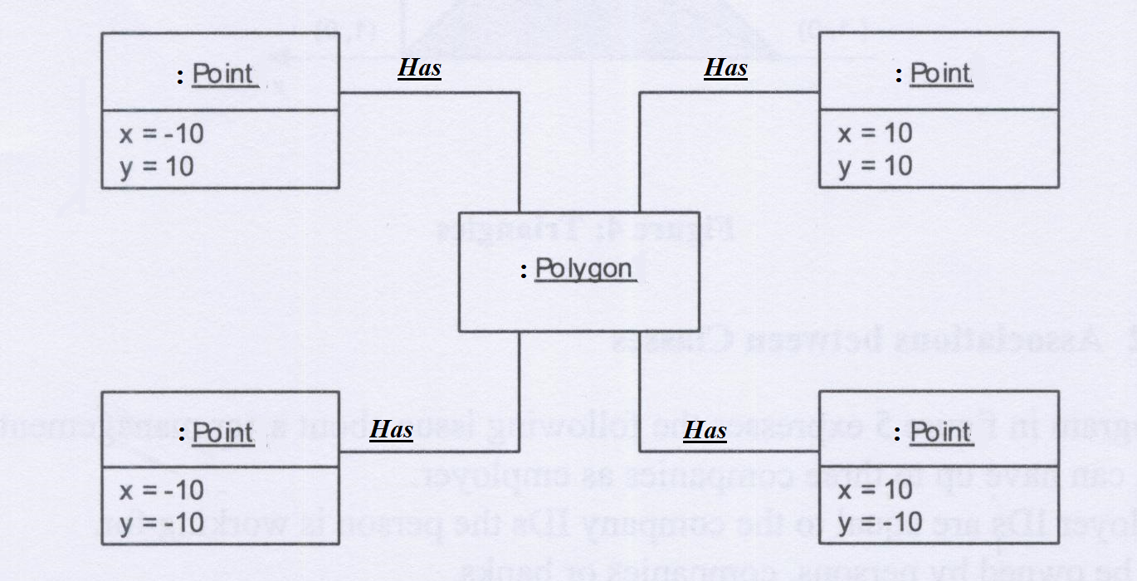

………………………………………………………………………………………………………………………………………………………………………………………………………….……………………………………………………………………………………………………
………………………………………………………………………………………………………………………………………………………………………………………………………….……………………………………………………………………………………………………
………………………………………………………………………………………………………………………………………………………………………………………………………….……………………………………………………………………………………………………
………………………………………………………………………………………………………………………………………………………………………………………………………….……………………………………………………………………………………………………
………………………………………………………………………………………………………………………………………………………………………………………………………….……………………………………………………………………………………………………
………………………………………………………………………………………………………………………………………………………………………………………………………….……………………………………………………………………………………………………
………………………………………………………………………………………………………………………………………………………………………………………………………….……………………………………………………………………………………………………
………………………………………………………………………………………………………………………………………………………………………………………………………….……………………………………………………………………………………………………

Best of Luck :)

